NEGATIVE NUMBERS
OCR Wednesday 8 November 2017– Morning (Calculator) Foundation Tier

AQA Monday 8 June 2020 – Morning (Calculator) Foundation Tier

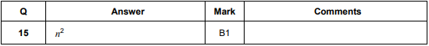
AQA Tuesday 6 November 2018 – Morning (Non-Calculator) Foundation Tier

